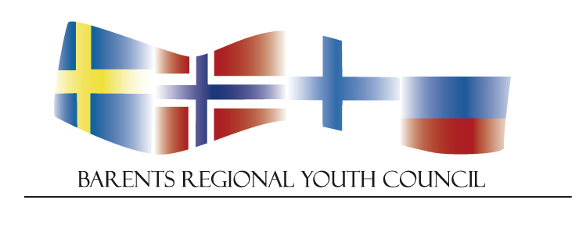
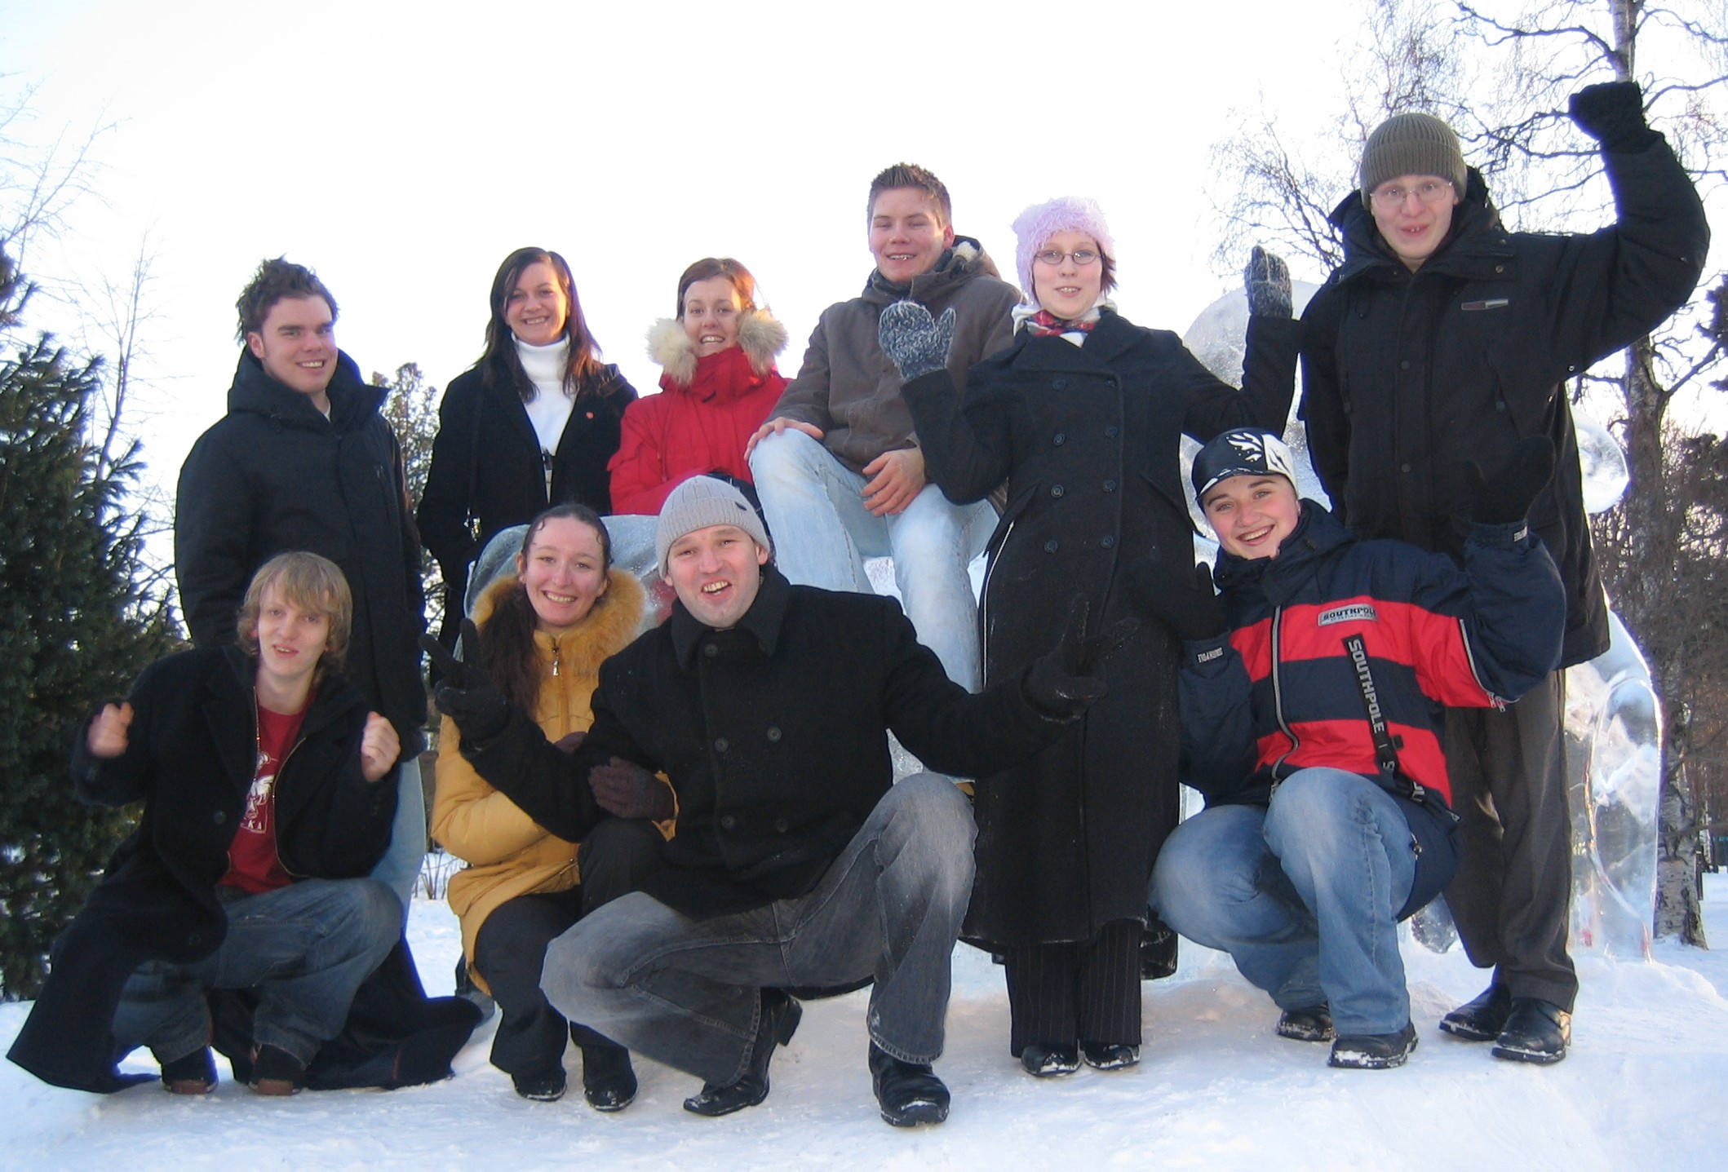

The Barents Regional Youth council

BRYC

Report 2013

The Barents Regional Youth Council

Our mission

We will strengthen the youth
cooperation in the Barents region
and empower young
people to actively participate
in the shaping of the
Barents region
and the society in which
we live.

-BRYC 2004

Introduction
At its meeting on 5 September 2001, the Barents Regional Council decided to draw up a youth programme for the Barents Region. This was done at the direct request of the Barents Regional Youth Forum, BRYF, which was represented at the meeting and called for concrete action. The present programme is based on the conclusions from the Conference “Face the Future”, which was held on 12-16 May 2001 in Tromsø, Norway. BRYF ended its work in 2003.

In 2003 The Norwegian ministry for children and family affairs allocated 1 mill NOK per year for two years to support multilateral youth projects in the region. The Norwegian Barents secretariat got the responsibility of managing the fund. A youth coordinator was employed and the extra recourses made a broader implementation of the program possible. The funding has continued until today and a new programme is developed.

Background
The countries in the Barents region have many common challenges when it comes to youth issues and this invites to increased cooperation about these matters.

During an international youth seminar in Murmansk October 2003, the participants strongly signalised that young people want to participate more actively in the Barents cooperation. They concluded that the best way to ensure this would be to establish a new youth structure in the Barents cooperation, a council consisting of young people from the whole region.

Establishment
The establishment meeting for the Barents regional Youth Council (BRYC) was held in Kirkenes during the festival Barents Spektakel 2004.

The council consists of one youth representative from each county, oblast, republic and okrug in the region and one representative for indigenous youths. The 14 members of the council will work towards a strengthening of the youth cooperation in the Barents region.

The members are chosen by their county administration based on the following criteria: - He or she must have an age fitting the category ”Youth” (over 18 and under 30 years) and speak English, have knowledge about youth issues in their region and be interested in international cooperation

Organisation
BRYCs secretariat is in the hands of the person responsible for the youth program at the Barents secretariat in Kirkenes. The Secretariat invites the members to the meetings, find suitable meeting dates and arrange travel and accommodation for the participants. The Barents Youth Cooperation Office (BYCO) in Murmansk have the responsibility to coordinate the participation of the representatives on the Russian side and make plans for travels, arrange visas and spread information BRYCs closest collaborator in the Barents cooperation is the Regional Working group on Youth Issues.

Activities

Council meetings
The Barents Regional Youth Council with all representatives meets normally twice a year. In 2012 the meetings were held in Tromsø, Norway and in Murmansk, Russia

Meetings in the council in 2013:

Annual Meeting and council meeting
4th -7th of April 2013
Luleå, Sweden
(enclosure 2 and 3 )

Council Meeting
3rd -4th June
Kirkenes, Norway
(enclosure 4)

Council Meeting
7th september in during studytrip
Brussels, Belgium
(enclosure 5)

Council Meeting
17th october
Luleå, Sweden
(Enclosure 6)

Board for BRYC
One contact person from each country, plus the indigenous representative is represented in a board for BRYC. The personal compositions board have differed in terms of the tasks, to ensure that the team always has interest in the particular task they are working on at the time. The board is elected every year during the annual meeting. Boardmembers 2012:

Zhanna Guzhenko, Russia
Alexander Falck, Sweden
Mari Kovala, Finland ?
Eirik Mofoss, Norway
Olga Egorova, Indigenous representative

Meetings in the Board for BRYC 2013:

There were not need to arrange separate meeting for the board during the spring, because of the gathering in Kirkenes during Barents Summit in June and the extra meeting during Brussels study trip. But a separate board meeting was arranged in December in Helsinki to work out the plan of action and start the preparation for next years event.

Study trip to Brussels
BRYC REPORT – BRUSSELS STUDY TRIP 6th SEPTEMBER 2013

Time: 09:00-17.00 Venue: Northern Norway Information Office in Brussels
Participants: BRYC-members (see final page), Andreas Østhagen (NN), Torjus Kleiven Kandal (NN), Mikael Jansson (NS), Jennie Larsson (NS), Kari Aalto (E&NF

09:00-11:00 - Meeting with the information offices of Northern Scandinavia
BRYC’s first topic on the agenda for the study trip to Brussels was a meeting with the representatives at the offices of Northern Norway (NN), Northern Sweden (NS) and East and North Finland (E&NF). Each office held a presentation about their organization, what it is that they do in Brussels and how their work affects the regions in their respective countries. After each presentation BRYC members had the opportunity to ask questions and talk to the representatives.

What follows are short summaries of the presentations from the various offices.

Northern Norway (NN) - Andreas Østhagen
The EU debate in Norway has become very polarized as of late. Either people are for or against the inclusion of Norway into the EU. Andreas, however, feels that this debate misses the central point. EU’s decision-making will affect Norway, whether the Norwegian people want to or not. Thus, it makes sense for Norway to be present in Brussels, at the heart of EU decision- and policymaking in order to promote its interests. North Norway represents Nordland, Troms and Finnmark and their respective interests In Brussels. EU’s (and global) interest for the arctic region is steadily increasing and this creates opportunities for the north Norwegian actors. Therefore it is important for the regions of northern Norway to be present and “on top of it”.

Northern Sweden (NS) – Mikael Jansson
North Sweden represents (mainly) the regions of Västerbotten and Norrbotten (and the actors within them) in the north of Sweden. While Sweden’s presence in EU is known, it is felt by the northern regions that the image that most people have of the northern parts of the country is a bleak and uninteresting one. The north part of Sweden is often considered as being just huge stretches of empty land with dark forests and mining industry, while some of this may or may not be true – there is more to this picture than meets the eye. The focus of NS is to “put northern Sweden on the EU-map”. By being and developing the EU’s future production of raw materials in a global market. But also by making efforts in the area of creativity, culture and innovation to show that the north of Sweden has more to offer than just raw materials.

Eastern and Northern Finland – Kari Aalto
Eastern and Northern Finland, (as the name implies) represent the regions of east and north Finland in Brussels. Combined, the regions account for 2/3 of the Finnish land area and have about 1.3 million people. The office works in Brussels with EU interest promotion and regional marketing. Like marketing and promoting Finnish competencies and following EU decision making while reporting back to the regions. They also arrange networks for both regional and European actors as well as partner searches (both-ways) and help in arranging events and visiting programmes in Brussels.

BRYC members also got a quick lecture on how EU is structured and how it operates. There may be opportunities for BRYC representatives to apply for internship at their respective country’s office. This could be a good source of knowledge and first-hand experience with EU policy-making that can be of value to BRYC and its future work. Also a general tip from the representatives of the various offices was that EU decision-makers are often easier to get in touch with than similar decision-makers at a national level.

11:00-13:00 – Meeting with the Russian Mission to EU
At the meeting with the Russian mission to EU the discussion, and subsequent questions posed to the representatives were primarily concerned with visa issues. To build relations between countries you must first build relations between people. People to people relations are therefore one of the focus areas and main reasons to oversee the visa requirement when travelling to and from Russia as an EU citizen and vice-versa for Russian citizens. Some examples (like Kirkenes) where the bordering nations has started experimenting locally with visa-free travel across borders were brought up. And from what the representatives of the Russian mission to EU indicated, most of these types of experiments have had very positive outcomes. Since young people travel more frequently, and travels seem to increase, the issue of visa-freedom is important for youths.

14:00-17:00 Meeting with Education, Audiovisual and Culture Executive Agency (EACEA)
At the EACEA BRYC members received two presentations on different parts of the EACEA and their function. An overview of EACEA was presented, and the impending re-organization of the different programmes and initiatives within the organization, knowledge of which will be important for EU project funding starting in 2014. There was also a presentation by representatives of the Youth in action programme.
BRYC Event 2013
Green Night

PROJECT REPORT

SHORT PROJECT DESCRIPTION /SUMMARY
One of the biggest challenges in the Northern areas and the one on top of the political agenda both on the regional and central level in Norway, Sweden, Finland and Russia is that many youngsters leave the region to go live in the South and that there are very few young people from the other parts of the country who wish to live in the Northern areas. That is why the region needs to be made attractive for young people through knowledge and first-hand experience about the quality of life and the real opportunities available in the north.
Barents Regional Youth Council arranged a project called ‘Green Night’ on the 17.-20: th of October in Luleå, Sweden. The aim of the project was to emphasize the ‘good life’ in the high north. The project contributed to increase the desire to live in; and spread the knowledge about the quality of life in the high north. The project gave young inhabitants of the Barents region understanding of the significance of correct, positive information and communication about the life in the north and importance about being proud of the societies we live in. The event itself had a special focus on the beautiful nature and sceneries that you can experience in the high north. The event also focused on the importance of taking care of the environment in the beautiful and vulnerable Arctic region.
This was accomplished by gathering together 80 youths aged 18-29 from the whole Barents region (20 from each of the countries Norway, Sweden, Finland and Russia divided among 13 member regions within the Barents region) with different cultural and ethnic background for 3 days in Luleå. Several parallel creative workshops was arranged, all with the focus on environmental issues that ended up in a joint cultural show on the final evening of the event. The show consisted of different small performances. The project was creative and exciting and served to involve the participants in important social and political questions in a new way through joint creative work.

BACKGROUND
Barents Regional Youth Council (BRYC) consists of one youth representative from each member region as well as an indigenous representative (14 people altogether).
Every year BRYC arranges a big international youth event that gathers the youth from all the member regions. Topics for the arrangements vary from year to year , for example in 2005 It was an indigenous and minorities festival in Kajaani, in 2006 – a youth conference in Tromso with rotating idea development for cooperation projects, in 2008 BRYC implemented a big gathering in Lulea ”YEAH RIGHT” with a focus on human rights and the project of 2009 ”reACTion- a performance against prejudice” that took place in Arkhangelsk where the aim was to prevent prejudice and racism by cooperation with people with different cultural background, ethnicity and sexual orientation.
The members of BRYC take part in other international events in the region and are invited to different seminars and conferences to tell about their international work and about their experiences. At such meetings there is group and process work where the youth from the region is invited to focus on challenges (problems) of living in the Nordic cap or in the Barents region.
However, it is the viewpoint of BRYC that this does not serve to promote life in the region. To stimulate a desire to live in the region one needs to focus on the good sides and opportunities as well as spreading this knowledge amongst people. BRYC therefore thinks that more attention should be focused on promoting the good life, the quality of life and the real opportunities in the high north.
BRYC has been planning to hold its annual event in Luleå since the annual meeting in November 2012 in Murmansk and made its final decision at the Luleå meeting in April 2013.

THE AIM
Green Night was arranged by and for young active and enthusiastic youths in the Barents region between the ages of 18 and 29. At Green Night the young people met across cultural and geographical borders to focus on the importance of taking care of our common environment as well as the good life in the north, stimulating the desire to live; and to make the region attractive for the young people both in- and outside of the region.
Green Night was a meeting point for building bridges between the youth of different nations and ethnic groups and an arena for international cooperation and joint process work. The project was used as a tool to promote equality among youth with different cultural backgrounds focusing on the common possibilities in the High North. The project also, by means of practical work, served to emphasize the quality of life in the North and served to put the important issues concerning the Barents cooperation on the agenda.
Green Night was open and flexible to the new trends and benefitted from the experiences of the work with other cross-border youth projects earlier held within the Barents region.

CONTENT
Green Night was arranged in Luleå on the 17-20: th of October 2013. The arrangement took 4 days in total; days 1 and 4 were travel days. Day 2 are 3 are given to process work (workshops) and finalizing the process work and arranging and executing the final show. Green Night had the following main parts:

PART 1 INTRODUCTION
The introduction of the event was inspiring lectures from Lars-Anders Baer and Frédéric Forsmark. Lars-Anders informed participants in how the environmental issues in the Barents region affect its indigenous population. Climate change affect their livelihood in many ways. The mild winter weather associated with global warming has made it considerably more difficult for the saami people to rely on traditional means of hunting game and herding reindeer. Frédéric discussed the regions environmental issues in general and encouraged participants to reflect, be skeptical and consider the facts because environmental issues are often not as simple as they seem. After the initial presentations the workshop leaders presented themselves to the participants and got to talk a little bit about their background and their ideas for the workshops. This also served to let the participants acquaint themselves with the workshop leaders more before the actual workshops started.

PART 2 WORKSHOPS
There will be 5 parallel workshops with a uniform distribution of participants.
Music workshop (Final show: Concert)
Slowfood workshop (Final show: Serve food)
Dance workshop (Final show: Dance performance)
Media workshop (Final show: Presentation of video/graphic work)
Art and fashion workshop (Final show: Catwalk/fashion-show)

Note: The final show proposals (parentheses) are suggestions. Final ‘product’ will depend on the workshop leader.

There was a professional workshop leader for each workshop who ensured that everyone contributed to the result at the final show. The workshop leaders also served to inspire and guide participants so that everyone has a creative and engaging work environment within the workshops. Leaders also (together with the organizers) determined what they would like the product of their respective workshop at the final show to be as well as how best to work in order to accomplish the final product in time.

At the registration to the event the participants specified which of the workshops they would like to participate in. The organizers were responsible for mixing the groups so that all of them consist of different nations and minorities.
This was important to reach one of the expected results of the project. As the event itself is arranged in order to be a meeting point for building bridges between the youths from different nations and ethnic groups. It was also be important for the event to promote equality among youths with different cultural background by being an arena for international cooperation and common process work.

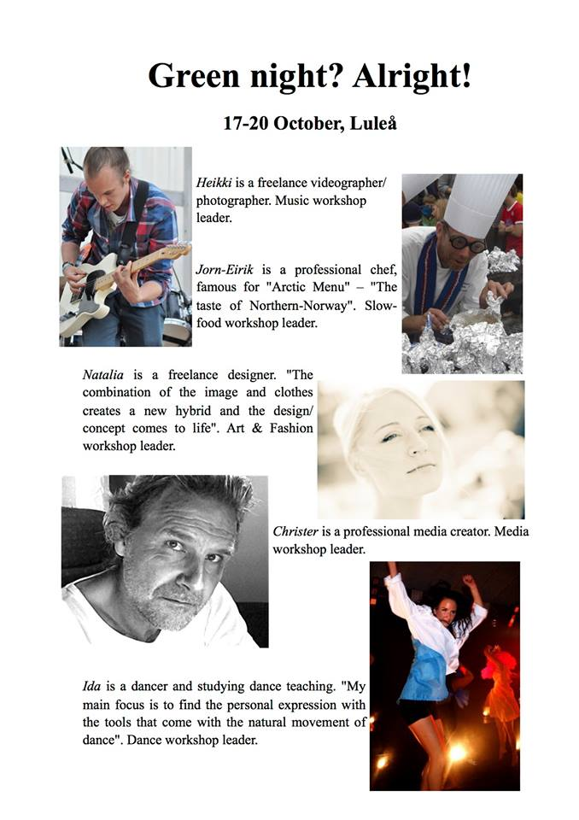
Music workshop
In the music workshop the participants had various instruments and musical equipment at their disposal. The participants together with the workshop leader rehearsed and performed several acts at the final show of Green Night.

The approach decided on by the workshop leader was a relaxed setting with one planned performance in which the participants had the opportunity to get to know each other, not just by verbal communication, but musical as well.

The participants of the music workshop arranged so that there would be one performance where all of them performed at the same time. After rehearsing together the group also split into different smaller groups in order to perform different individual songs. This way, they both had a chance to play together as a an ensemble and also perform different projects in smaller groups. Participants took turns in rehearsing with the different instruments and spontaneous jam-sessions could seen in different locations of the conference building.

Slowfood workshop
The Slowfood workshop consisted of both theoretical know-how and practical hands-on experience. The workshop started out on a theoretical basis in the form of lectures from the workshop leader. After the initial lectures the participants received hands-on cooking experience and got to try their hands at making different dishes inspired by typical Barents region -ingredients.

The reasoning behind having the workshop structured in this way, (lectures → cooking) was to give the participants both a background knowledge of the ”how's and why's” as well as practical instruction and experience in cooking.

The first day of the workshop was dedicated to lectures and preparation. The second day was used for cooking. Originally, the idea was for the workshop to present their cooking at the final show of Green Night, but due to complications in the policy of transferring foods from one restaurant to another this idea unfortunately had to be scrapped. The workshop, instead, presented their work the afternoon coffee-break on the second day of the event. This consisted of a veritable buffé of sushi that all of the participants from the different workshops got to try. Judging by the amount of remaining sushi pieces at the presentation-table after the break the ”performance” was much appreciated.

Dance workshop
Dancers in the dance workshop coordinated a group performance, performed at the final show of Green Night.

Because of the varying previous dancing experience of the participants in the dance workshop the performance had to accommodate for the difference in skill levels. This was handled well by the workshop leader.

On the first day, participants could be seen dancing out of the workshop locale for the first coffee break. Later on during the afternoon, participants were considerably more sluggish, and many (all the while smiling) admitted to being a little tired after all the dancing. In the final show the workshop participants performed a coreographed dance depicting man's influence on nature. After the performance the dancing participants had gone out of their way to present their workshop leader with a small gift in return for her excellent work.

Media workshop
Media workshop participants shot raw video footage from different locations around the conference location and in the city center of Luleå using several cameras. This raw video footage was then edited and presented in the format of documentaries and music-videos at the final show of Green Night.
The media workshop group was primarily tasked with documenting the event so that a video showing the participants working in their respective workshops could be made. As participants had some free time on evenings to socialize they were mostly hard at work during the day. The idea was to document the different workshops in order to show the participants how their colleagues worked on their projects.

The first day of the workshop was dedicated to learning how to operate the video equipment and shooting of actual video content. The group had several cameras available and after discussing what to shoot, split up into smaller groups spread around the conference area, the different workshops and Luleås' city center. During the second day the participants finalized shooting the video content and edited the raw video footage to produce the final cut products. These were then aired using a projector in-between acts at the final show of Green Night. Given the amount of work involved in directing, shooting and editing the video footage the media group was working up until the very last moment before the final show started, the result that they produced however, was well worth the wait.

Art- and fashion workshop
In the art- and fashion workshop participants had access to second-hand clothing, materials and equipment in order to create their very own fashion designs presented at the final show of Green Night in a “Runway-style” format.

The art- and fashion workshop was one of the smaller workshops so the participants did not have to compete for the attention of the experienced workshop leader. The equipment for the workshop well accommodated the needs of the participants.

Participants of the workshop got to work creating their very own fashion garments from a varied host of second-hand clothing under the instructions and tutelage of the workshop leader from the very first day. At the final show the participants had produced various creations that they showed off during their runway fashion show that was co-created with the music workshop that were set to play the music for the fashion-show. The participants received applause for their hard work and creative design from the other workshop groups.

PART 3 FINAL SHOW
The final show was arranged on a boat and consisted of various performances and showings of the work that had been done within the different workshops. It was open for interested organizations to inform about their activities in the context of youth projects and cooperation locally and within the Barents region. Våga had a short presentation about their work. It was also be possible for the various participants of the event to meet up with local youths to network and discuss ideas for possible future projects. The final show also served as a farewell party for the participants to mingle and reflect upon their experiences of the event before they travelled back home to their respective regions, with lots of memories, friendships and contacts in the baggage.

RESULTS
The project contributed to an increased engagement in environmental issues, a desire to live in- and knowledge about the quality of life in the Barents region. The project improved the dialogue between the participants concerning the meaning of good life in the high north. The participants actively used their new experiences and new knowledge in conversations with other people in and outside the region.
By communicating with others and contributing in the event the participants get a better self-understanding. This is because they realized their talents, skills, interests, reactions type, feelings and behavior. There was a process where the positive side will be strengthened and the negative sides are controlled. A performance that raises and emphasizes the peculiarities of different cultures will give a ground to learn more about own identity and bigger assertiveness and a capacity to use cultural tools. Intensive cooperation with non-familiar people where everyone has to give and take gives experience of conflict solution, individual and in a group. The participants took part in exercises to learn more about behavior, communication and cooperation in the group to get better skills of team work.
This project gave experience on how to work with important socio-political issues through
international youth meetings in a concrete and different way. The methods will be evaluated and can be used in other cases where one wants to use the creativity and culture to raise the important and heavy issues.

Information and other activities
The representatives of BRYC have informed local and regional NGOs in their Counties about larger Barents Youth events. The information flow has a great potential for improvement and all members are now building up their own list of addresses in their mailbox to be able to forward messages and links.

Other ACTIVITIES, representations and presentations

Johan Berglund, Norrbotten SWEDEN
Meeting with the county administrative board of Norrbotten, 20th February 2013
Was admitted into BRYC as the representative of Norrbotten County

BRYC-meeting in Luleå, 4-7th of April 2013
Annual meeting, planning of annual event in Luleå at autumn. Meeting with the county administrative board of Norrbotten and Norrbotten's läns landsting.

Partaking in a lecture on BRYC given at the county administrative board's offices in Luleå 12th of April 2013
Short information on BRYC, presentation together with Alexander Falck and Laila Dalhaug (present via video-conference link).

Meeting with the county administrative board and Norrbottens läns landsting on the BRYC-event 18th of April 2013
Brainstorming, preparations, contacts and venues were discussed.

Meeting with Marit Lemberg of the Föreningen Norden organization, division of Norrbotten
Question was raised as to whether BRYC would like to participate in the Nordkalotten-conference 2014 in Kiruna.

BRYC-Event in Luleå 17-20th of October 2013 (continuously during the year)
Planning and contact with travel agency Norrbottens Resebyrå. Recieved and forwarded offers on lodging, food, equipment and venues for the event to the Barents Secretariat in Kirkenes. Responsible for practical issues on-site before, during and after the event in Luleå.
Managed applications for project funding to the county administrative board, Norrbottens läns landsting and the municipality of Luleå.
Partook in the writing of the final report for the event by contributing articles on the different workshops and presentations.

Barents Summit 2013, 2-3 June 2013
BRYC-meeting and representation at the ceremony.

Recruitment of participants for “Project-Z” 2-4th of August 2013
Responsible for finding participants from Norrbotten.

Study-visit Brussels 5-9th of September 2013
Meeting with North Norway, North Sweden, Russian mission to EU and EACEA
Participation in BRYC-meeting 7th of September
Writing protocol for the BRYC-Meeting in Brussels
Writing of report regarding the BRYC-meeting in Brussels, documenting the study-visit

Meeting with the Föreningen Norden organization on the Nordkalott-conference 2014, Haparanda
Partaking in planning, discussion of content in the conference

Eirik Mofoss, Troms, Norway

BRYC-activities 2013
When? | What? | Description
10-12. January 2013 | Barents +20, Kirkenes. | Held a presentation about BRYC with the title: “Youths’ future in the North” . Interview on radioNRK afterwards.
5-6. February | Kirkeneskonferansen 2013 | Participated.
19-20. March 2013 | Conference on foreign languages in the North, Tromsø | Teachers' conference on foreign languages (Finnish and Russian), Tromsø. I held a 45 presentation about "The importance of learning foreign languages"
4-7. April 2013 | BRYCs Annual Meeting and Council Meeting, Luleå.
3-4. June 2013 | Barents Summit, Kirkenes | Participated in the meeting of our prime ministers
5-8. September 2013 | Study trip to Brussel and BRYC-meeting
23-25. september 2013 | EEA-conference about regional cooperation in Košice, Slovakia | I was invited from BRYC to hold a speech about “Cross-border youth cooperation – BRYC as an example”. The conferansen was supported by, among others, the Norwegian Barents Secretariat
17-20. October 2013 | «Green Night», Luleå.
28-29. October 2013 | 14th session of the Barents Euro-Arctic Council, Tromsø | Only youth representative at the meeting. I told about BRYC, our work and vision. Also, I asked questions to the foreign ministers of our region about issues regarding us youths.
30-31. October 2013 | Conference from teachers of the Russian language, Tromsø | Arranged by Fremmedspråksenteret (The Norwegian Centre for Foreign languages in Education). I told about my own experiences and how I learned Russian.
31. October 2013 | Meeting on possible cooperation between BRYC and the business sector. | Meetin with Rune Kufaas and Sigrid Mogård at Sjurelv AS, discussing possibilities for future cooperation.
11. December 2013 | «Russland – mulighetenes land» («Russia – the country of opportunities»). Essay published by NRK about High North politics and why Norwegian youths should look towards Russia, our neighbor.  http://www.nrk.no/ytring/russland-_-mulighetenes-land-1.11406939

Svetlana Gusheva, Arkhagelsk, Russia
Youth from Arkhangelsk region shows great interest to participation in international projects and events. Traditionally most part of them is conducted with our partners and neighbor-countries from Barents region (Norway, Finland and Sweden).

Participation in BEAR projects helps young people to improve social, cultural and professional competences. All in all, these events call to create an image of Barents region as an area of possibilities, that is inviting for living, education, professional and personal progress.

The section of development of international youth cooperation was included in Arkhangel region long-term goal-oriented program “Pomor Youth (2012-2014)” with annual budget for co financing of international youth projects up to 200 000 rubles. From 2013 onwards projects, developing international youth cooperation are included in the draft of Archangel region program “Patriotic education, improvement of physical culture, sport, tourism and efficiency advancement of realization of youth policy in Arkhangelsk region in 2014-2020” (youth policy section).

Arkhangelsk region participates in Barents international youth cooperation on several levels:

1. Participation in activities of joint BEAR workgroup on youth - JWGY (public officers). Arkhangelsk region ministry of youth and sports is an official member of joint BEAR workgroup on youth since its’ foundation in November 2011.
Minister of youth and sports Elena Dotsenko is a member of this workgroup and takes part in meetings representing projects of Arkhangelsk region. As a result the number of BEAR projects on development of youth international cooperation with assistance of ministry and number of participants increased in 2012 (there were only 20 participants in 2011 and more than 100 in 2012). Further increase in number of international projects and its’ participants is planned for 2013. According to preliminary accounts the ministry approved 7 international youth projects with total amount of participants more than 600.

2. Participation in activity of Barents Regional Youth Council (BRYC) – a representative body of BEAR countries youth. Members of BRYC participate in common meetings with official BEAR workgroup on youth in different countries and regions of BEAR at least 2 times a year. Membership in BRYC gives a perfect ability to elaborate and implement youth projects of home region, to acquire a lot of useful contacts and achieve valuable experience in management of international projects.
Election of a new Arkhangelsk region representative to the Barents Regional Youth Council (BRYC) occurred on 4 April 2013. This voting was conducted by common assembly of youth social unions and initiative groups in agreement with regional authorities. It is mentioned that it is necessary to increase the role of BRYC members as experts in projects’ assessment within the framework of Barents Regional Youth Program and evaluate activity of representatives according to the number of requests to the program. The new member of BRYC from Arkhangelsk region us Svetlana Guseva, a student of department of region studies and foreign affairs at NARFU.

3. Participation of Arkhangelsk region youth in BEAR international youth conferences and seminars. In 2012 youth delegates from Arkhangelsk region took part in two remarkable youth events of Barents region – the conference “Our Barents – Our Future. A new agenda for Barents cooperation” in Finland (13-14 June 2012) and “Barents Youth Conference 2012” in Norway (22-24 October 2012). During the last one representatives from Arkhangelsk region obtained a unique possibility to contribute their propositions to the project of international intergovernmental document – The Kirkenes Declaration 2.0. In 2013 the youth delegation of 5 persons from Arkhangelsk region took part in the annual international youth event of BRYC – Green Night 2013. It was devoted to problems of environmental protection within youth participation.

4. Carrying out of international youth events in Arkhangelsk region
Since 2011 foreign youth representatives take part in activity of annual Arkhangelsk international forum “Team-29” (representatives from Norway and the USA in 2011 and from Norway and Finland in 2012). Within the framework of forum there is an international board. Working language – English. In 2013 there were 2 international board during the forum: ecological and creative.
Also our Norwegian partners take part in Arkhangelsk international forum of young entrepreneur s on a regular basis (being conducted since 2011).

5. Implementation of international youth projects 2013

Number of international youth projects and events
1. International Jazz Festival “Severnye Zemli – Nordic Lands” at regional Youth palace – more than 200 people.
2. Project “Pomor Land – The Capital of Youth Cinema”. It was conducted due to assistance of Barents Youth Film Academy – more than 200 people.
3. Participation in the project activities of “Centres of creative industries” of Council of Ministers of Northern Countries – 50 people.
4. International ecological section “Sustainable development of Barents Euro-Arctic Region with Youth Participation” during forum “Team-29” – 25 people.
5. International Jazz Festival and master-classes within the project “UrBand Camp”. Number of participants: from Norway – 35 people, from Russia – 55 people.
6. Project “ARCtic ARTiculation”. Number of participants: from Norway – 20 people, from Russia – 29 people.
7. Participation of Arkhangelsk region youth in annual international youth event of BRYC – Green night 2013 – 5 people.
8. Project “Festival of Cultures (CULTFEST)” at regional Youth palace (21 September 2013) during the international project of regional section of international youth organization AIESEC «Taste the World» – about 100 people.

Within the framework of Arkhangelsk region long-term goal-oriented program “Pomor Youth (2012-2014)” ministry of youth and sports of Arkhangelsk region provides financial support of social youth projects (according to results of regional project competition) including international. In 2013 the ministry supported implementation of following international projects involving youth:

1. International Jazz Festival “Severnye Zemli – Nordic Lands” that took place on 22-24 March 2013 with cooperation of Norwegian performers at the regional Youth palace.

2. “Pomor Land – The Capital of Youth Cinema” was organized due to support of Barents Youth Film Academy.
On 21 September 2013 there was an international film show with musical accompaniment (“live musik”) (the film “A nail in a shoe”). It was organized by International Film Festival, Tromso, Norway (TIFF). Location – “Rus” cinema. This film show was included in official cultural program of Margaritian fair-2013.

3. Project “Festival of Cultures (CULTFEST)” at regional Youth palace on 21 September 2013 within the framework of international project of «Taste the World».
Festival of Cultures was conducted during the international project "Taste the World" by the regional section of international youth organization AIESEC. Here at the Festival of Cultures you can get along with foreigners on probation period in Arkhangelsk. You can plunge into the atmosphere of international festival and cultural diversity. Master-classes of trainees from China, Egypt and India, creative concert from Polish, Columbian and Tunisian students and many other activities took place.
As a part of the article “Development of international youth cooperation” of Arkhangelsk region long-term goal-oriented program “Pomor Youth (2012-2014)” the support was given to two international youth projects during 2013:

1. Project “ARCtic ARTiculation” – September 2013.
Two creative camps were put up in Noway (in Kabelvåg) and in Arkhangelsk in September 2013. An exhibition of artworks by participants of this project and presentation of art-object – decorative wall-painting on topic “Nordic Cities” were organized during the Margaritinskaya Fair in the regional Youth House.

2. International Jazz-festival and master-classes within the project “UrBand Camp” – September 2013. During this year the musical festival and master-classes were held on 9 musical genres. Also a guest-tour to Kotlas and Kargopol was conducted.
Also Arkhangelsk region the ministry of youth and sports takes part in Council of Ministers of Northern Countries (CMNC) project “Centre of creative industries”. Following joint events are planned within the project: open lectures and master-class on contemporary photo/video art “Changing city” on 29-30 April; practical seminar on implementation of youth creative ideas “How to earn on creativity?” on 15-16 July 2013 (within annual youth forum “Team-29”).

List of international youth events (2012-2013)
№ | Event | Goal | Organizer | Place and time of event
1. | International ecological camp (section) “Think in ECOstyle” within annual youth forum “Team-29” | Improvement of international youth cooperation within BEAR, elaboration of joint ecological projects among BEAR countries | AETAS, Arkhangelsk region ministry of youth and sports | 26-30 July 2012  Ski stadium named after Kuzin (Primorskiy district, Arkhangelsk region)
2. | Project “The Pomor way”  Youth historical expedition (participants were 14-18 years of old) from Arkhangelsk to Vardø | Spreading the information about BEAR among youth, improvement of international youth cooperation within BEAR | “Cultural Pomor autonomy”; AETAS; Arkhangelsk region ministry of youth and sports | August 2012  Expedition along the way from Arkhangelsk to Vardø
3. | IX Russian-German forum for young journalists (topic-2012 – “Scientific journalism in Russia and Germany”). | Improvement of friendship and partnership between Russia and Germany, exchange of experience among young Russian and German journalists | Board of administration of Russian-German forum;  German ministry of foreign affairs;  Robert Bosch fund | Arkhangelsk  October 2012
4. | International jazz-festival and master-classes within the project “UrBand Camp”  During this year the musical festival and master-classes were held on 9 musical genres. Also a guest-tour to Kotlas and Kargopol was conducted. | Improvement of cultural and youth cooperation within BEAR, support of youth professional training | IntraAct Productions (Norway), Arkhangelsk regional volunteer organization ARVO | Arkhangelsk  11-14 October 2012  19-24 September 2013
5. | Project “ARCtic ARTiculation”  Two creative camps were put up in Noway (in Kabelvåg) and in Arkhangelsk in September 2013. An exhibition of artworks by participants of this project and presentation of art-object – decorative wall-painting on topic “Nordic Cities” were organized during the Margaritian fair at regional Youth palace. | Spreading the information about BEAR among youth, improvement of international cultural youth cooperation within BEAR | Norland arts and cinema college (Kabelvåg, Norway);  Norwegian Barents Secretariat;  ГБОУ СПО of Arkhangelsk region “Arkhangelsk college of arts and culture”;  Arkhangelsk region ministry of youth and sports | Arkhangelsk and Kabelvåg, Norway  August-September 2013 года

List of foreign visits (2012-2013)
№ | Event | Goal | Organizers | Place and time of event
1. | Participation in the meeting of BEAR joint workgroup for youth affairs - JWGY (1 person) | Improvement of cooperation among BEAR countries in field of international youth cooperation, implementation of joint youth affairs and elaboration of international youth projects | Norwegian Royal ministry of child affairs, equality and social integration | Tromsø, Norway  18-20 April 2012
2. | Participation in the youth conference “Our Barents – Our Future. A new agenda for Barents cooperation” (6 persons). | Improvement of international youth cooperation among BEAR countries | Administration of Norrbotten province | Tornio, Finland  June 2012
3. | Participation in youth conference of Barents region and in activities of joint BEAR workgroup on youth affairs -JWGY (5 persons) | Improvement of cooperation among BEAR countries in field of international youth cooperation, implementation of joint youth affairs and elaboration of international youth projects | Norwegian Royal ministry of child affairs, equality and social integration | Tromsø, Kirkenes (Norway)  22-24 October 2012

Alexey Tsykarev, Karelia, Russia

As I came to the Council in August 2013, not so much activities have been done during this time.
The only event I attended in my capacity as a BRYC member was the V Youth Economic Forum in Petrozavodsk.
I was a key speaker at round table «Youth initiatives in international cooperation».
The theme of my intervention was «The youth of the Republic of Karelia and a northern style of life: Youth cooperation in the Barents Euro-Arctic Region».
The dates: November, 14.-16.

For more information you can go to the forum’s website http://econforum.ru/index.html

During last year I addressed twice the Youth Parliament of the Republic of Karelia on issue of Barents youth cooperation.

One more event I participated in was the international conference «Native languages in the contemporary conditions of bilingualism» in Syktyvkar, October, 28.-30.

Julia Lapshina, Komi Republic, Russia

December 2013- a presentation of the annual BRYC event held in the Syktyvkar State University

January-December 2013 - articles regarding BRYC's activity in local newspapers and university newspapers.

10-14 September 2013 The international eco-tourism forum "The HEDGEHOG"

28 – 30 October «Native languages in the contemporary conditions of bilingualism» international conference

Ekaterina Burdikova Nenets, Russia
1. Performance of the Student theatre "Ulibka" in Bronnoysund within the peace painting project.
2. Participation of the 8 Nenets scouts in the Global friendship summer camp in Bronnoysund.
3. Participation of youth football team of the Zapolyarny Rayon in the Nilut Cup in Kautokeino.
4. Recruiting participants for the BRYC annual event.

Zhanna Guzenko, Murmansk, Russia
4-7 April 2013 - BRYC Annual Meeting in Luleå
5-8 September 2013 - Study trip to Brussels
29-30.10.2013 - JWGY meeting in Oslo
17-20 October 2013 - Annual event implementation «Green night»
November-December 2013 - Elections of Murmansk representative in BRYC

Major Challenges and future plans

Turnover
The turnover among the members have been high for some of the member regions, but there have been a quite stable group for some time now. For some of the regions it been necessary to look for potential future members constantly. The different youth structures in the counties and within the respective countries also make difficulties for recruitment of members. Some members are appointed while others are elected. Its necessary not to have rigid rules, but to be flexible.

Information
More effort must be done to ensure the information flow to regional NGOs, politicians and media to show the activities within the youths sphere in Barents.The website www.barentsyouth.org has renewed in 2013.

Training

To increase the member’s skills for international cooperation and coordination of activities, BRYC is arranging project management and leader training seminars. They also take part in courses arranged by others.

Youth participation

The UNs Convention on the Rights of the Child states that children and youths have the right to be heard in all matters that concerns them. This demands that the adults take the responsibility to crate the structures and arenas where this takes place.

The Convention acknowledges that children and youth have the right to express their opinions and to have those opinions heard and acted upon and that they have the right to take part in decisions. It is of major importance that we show that we take this seriously and that we show and act according to our attitudes weather it comes to rights of the child, human rights or equality of genders in the Barents cooperation.

Youth are a priority group in the Barents cooperation and it is about time that BRYC is invited to all the arenas where decisions are made- The Regional committee and the Barents regional council. Furthermore it is important that the youths have a vote there to make sure they have real influence and don’t participate only as observers.

Enclosures:

- BRYC members 2013
2.-6. BRYC meetings
- Plan of action 2013
- Regulations for BRYC
- Accounts 2013
- Accounts Green Night

BRYC Members in 2013
Name | County
Rikke Håkstad | Troms (stand-in)
Eirik Mofoss | Troms
Henry Ellingsen | Nordland
Mari Kovala | Lappland
Sunna Kokkonen | Lappland (stand in)
Ande Trosten | Finnmark
Isa Tolonen | Kainuu
Zhanna Guzenko | Murmansk
Anna Rybalova/Alexei Tsykarev | Karelia
Julia Lapshina | Komi
Svetlana Averyanova/ Svetlana Guseva | Arkhangelsk
Andrey Vokuyev | Nenets
Ekatherina Burdikova | Nenets (stand in)
Johan Berglund | Norrbotten
Johan Miranda | Västerbotten (stand-in)
Alexander Falk | Västerbotten
Olga Egorova | Indigenous repr.

